**Online Restaurant Management System**

**By**

**Sugandh Gupta**

The Online Restaurant Management System provides convenience for the customers. It overcomes the disadvantages of the traditional queuing system. This system increases the takeaway of foods than visitors. Therefore, this system enhances the speed and standardization of taking the order from the customer. It provides a better communication platform. The user’s details are noted electronically. This System set up menu online and the customers easily places the order with a simple mouse click. By using the food menu online anyone can easily track the orders, maintain customer's database and improve food delivery service. This system allows the user to select the desired food items from the displayed menu. The user orders the food items.

The payment can be made online or pay-on-delivery system. The user’s details are maintained confidential because it maintains a separate account for each user.

## Use-Case Diagram for Online Restaurant Management System

A use case diagram at its simplest is a representation of a user’s interaction with the system and depicting the specifications of a use case. A use case diagram can portray the different types of a system and the various ways that they interact with the system.

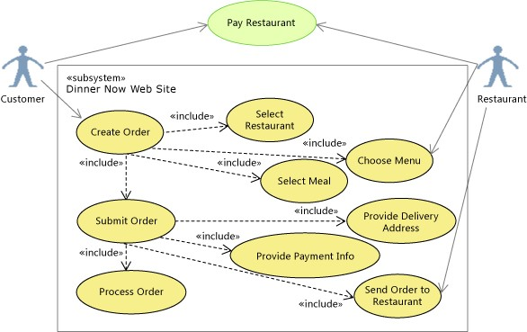

Use-Case Diagram for Online Restaurant Management System

**Class Diagram of Online Restaurant Management System**

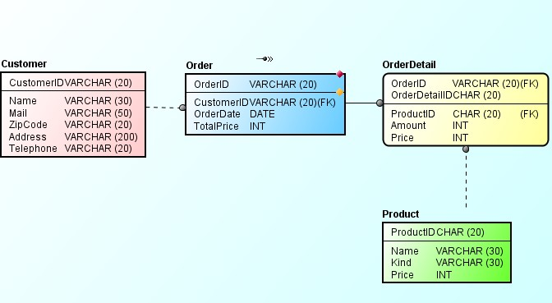

Class diagram of Online Restaurant Management System

## Sequence Diagram

A Sequence diagram is an interaction diagram that shows how objects operate with one another and in what order. It is a construct of a message sequence chart. A sequence diagram shows object interactions arranged in time sequence.

### Sequence Diagram for Customer

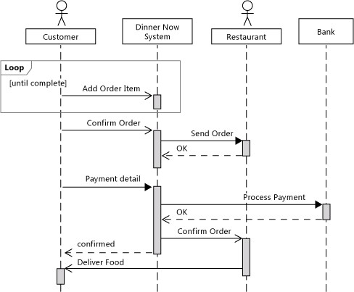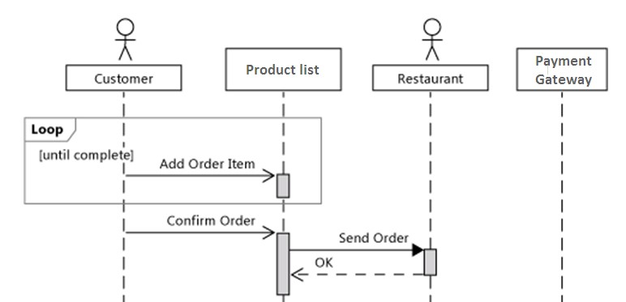

Sequence Diagram for Customer

### 4.3.4 Sequence Diagram of Online Restaurant Management System

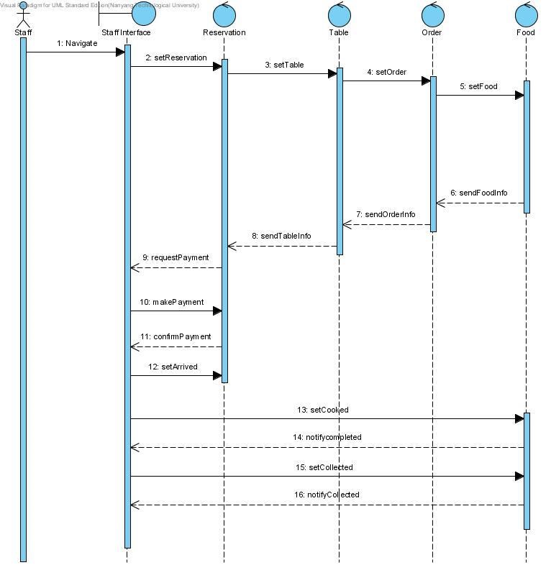

Sequence Diagram of Online Restaurant Management System

### Entity-Relationship Diagram

An entity-relationship diagram (ERD) is a data modelling technique that graphically illustrates an information system's entities and the relationships between those entities. An ERD is a conceptual and representational model of data used to represent the entity framework infrastructure [15].

### Relational Model for Online Restaurant Management System

User (id, user_login, user_pass, user_nikename, user_email, user_url, user_registered, user_activation_key, user_status, display_name)

Item (order_item_id, order_item_name, order_item_type, order_id)

Options (option_id, option_name, option_value, autoload)

Usermeta (umeta_id, user_id, meta_key, meta_value)

Comments (comment id, comment_post_id, comment_author, comment_author_email, comment_author_url, comment_author_IP, comment_date, comment_date_gmt, comment_content, comment_karm, comment_approved, comment_agents, comment_type, comment_ parent, user_id)

### E-R Diagram for Online Restaurant Management System

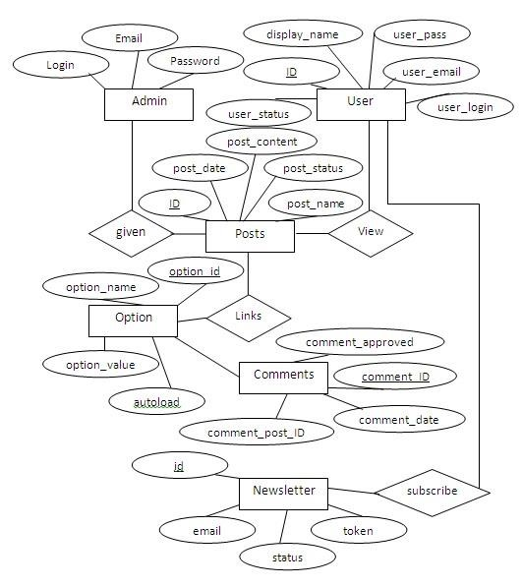

E-R Diagram for Online Restaurant Management System